Writing Workshop: Getting Started with Story
Jean C. O’Connor
Author of The Remarkable Cause: A Novel of James Lovell and the Crucible of the Revolution (Knox Press, 2020)
Recipient of the NCTE High School Teacher of Excellence, 2018
Montana Association of Teachers of English Language Arts Distinguished Educator
Montana Writing Program, U. of Montana
English, History teacher 37 years, 22 at Helena High School, 3 years Literacy Coach
jeanoconnor.com, contact@jeanoconnor.com
Lewis & Clark Library, Helena, MT
September 25, 2021

What kind of writer are you? Why does knowing more about your writing style matter?

Chunker
Here you start with an idea. It may lie in the middle of the story, at the end, or at the beginning. You write and develop that idea, then go on to another. When you are ready, you write the beginning and end, then tie the pieces together with transitions.
Incubator
You think about the development of your writing, the sequence, new ideas, the focus. When you are ready, you sit down and write what you have conceived, the entire thing, from beginning to end.
Outliner
You need to create definite order before you write. You note main ideas, then under each add details. You create lists, then change, sequence, and shape ideas until you have an order, then you form an outline. From this you can write your piece.
Explorer
Here, you may have an idea, but you need to start writing until you find out how you want to say it. By writing, you discover the way you want to write your piece.
Noter
Your writing process begins with notes, scribbled, doodled, or written with pictures or symbols. You jot your ideas down, then connect ideas with lines, circles, or numbers. You organize these, and then can begin writing.

From Richard Adler, who taught at the U. of Montana for many years (retired in 2000), in Writing Together.

Sites such as https://www.squibler.io/blog/types-of-writers/#Types_of_Writers_Fiction
embellish on these by using terms such as “planners and pantsers,” or those who outline rigorously and those who “fly by the seat of their pants.”

What do you Like to Write?

Poetry | Fiction (short story, novella, novel)  Fantasy  Science Fiction  Mystery | NonFiction  Narrative Nonfiction  Biography/Autobiography  Memoir | Drama

Does Research Play a Role in Development of Your Story?
Consider Primary Sources. From the Library of Congress:
“Primary sources are the raw materials of history — original documents and objects that were created at the time under study. They are different from secondary sources, accounts that retell, analyze, or interpret events, usually at a distance of time or place.”
Locate Primary Sources online, in closets, family collections, newspapers….
They can include these:
- archives and manuscript material.
- photographs, audio recordings, video recordings, films.
- journals, letters and diaries.
- speeches.
- scrapbooks.
- published books, newspapers and magazine clippings published at the time.
- government publications.
- oral histories.
Newspapers:
The Montana Historical Society hosts an awesome collection of historical newspapers: https://mhs.mt.gov/research/collections/newspapers/mtnews
Also, find here a link to Chronicling America, 90 newspapers.
Other Sources:
A vast number of primary sources are available online. Consider FOLD3, military records; Library of Congress Prints and Photographs Online; New York Public Library Digital Collections; old digitized books in HathiTrust, Google eBooks; museum resources.

Focus: Two Ways to Plot
Planning is important. You don’t need to know all the twists and turns a narrative might take, but in general, how do you want the action to proceed? Where is the character going, and what will he or she learn?
A Word About Other Elements of Writing Fiction: Numerous sources can help you consider elements such as theme, point of view, grammar, punctuation, and writing tips. One of the best and most convenient is Purdue OWLS. Access its site map for a quick review.

STORY ARC
The Plot Whisperer: Secrets of Story Structure Any Writer Can Master, by Martha Alderson
In general, knowing your story arc is vital.
The Universal Story: elements which all stories have in common.
Note: Most Plot Charts look more like this:
The Beginning: Comfort and Separation
The Middle: Resistance and Struggle
Halfway: A major turning point
The Crisis
The End: Transformation and Return
Climax
Resolution
On large (six feet long is suggested) paper, draw your plot line.
On it, note scenes for the Beginning (1/4), Middle (half-way), Crisis (next ¼), Climax and Resolution (last ¼).

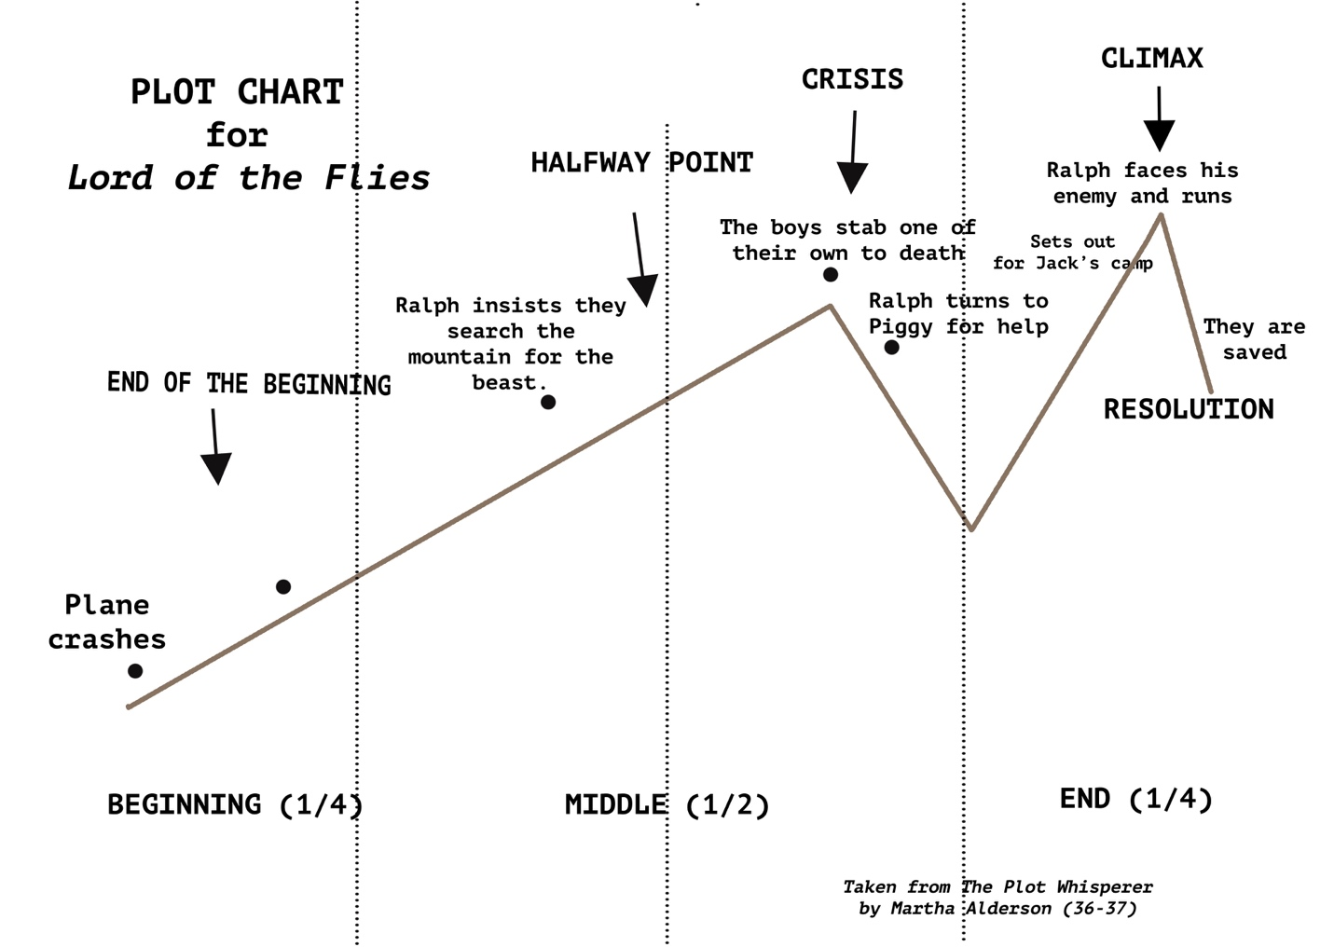

THE HERO QUEST
Another way to envision a story plot is the hero quest story; the stages of the Hero Quest are adopted from Joseph Campbell’s The Hero with a Thousand Faces. See handout for questions to help guide you through the development of each of these stages; a chart example is below and on the Hero Quest handout.

Part I: The Separation
1. THE CALL: Everything is going to change for the person.
2. THE THRESHOLD: The person ventures into an unknown and dangerous realm.
3. THE DESCENT: The person shows willingness to undergo a metamorphosis, to die to him or herself.

Part II: The Initiation
4. TESTS AND ORDEALS: Tests, tasks, or ordeals, usually in a series (three) that the person must undergo; often the person fails one or more.
5. INTO THE ABYSS: The greatest challenge of the journey; the initiate must face the abyss alone and "slay the dragon,” the thing the hero most dreads and needs to overcome.
6. THE TRANSFORMATION: As a result of successfully meeting the challenge of the abyss, the hero is transformed. This is the moment of death and rebirth, often changing the way the hero(ine) views life.
7. THE ATONEMENT: The initiate accepts his or her new transformed self and reaches harmony with life and the world. The goal of the quest has been achieved.

Part III: The Return
8. THE RETURN: Using the wisdom gained on the quest, the person must integrate that into life, and then maybe figure out how to share the wisdom with the rest of the world.

A Wizard of Earthsea
By Ursula K. LeGuin
The
Transformationn

Ged flees the shadow, taking a boat far out to sea.
The
Atonement
Into the
Abyss
Ged withstands temptation to give him ultimate power.
Tests &
Ordeals
At the School, Ged summons the spirit of the dead, a banned spell.
The shadow pursues Ged as he travels to the School for Wizards.
The
Return
Ged recognizes his power and his limits; he is in balance.
Ged embraces the shadow, naming it Ged, mastering his fear.
Ged summons danger by reading a forbidden spell.
Hero Quest
The Thresholdd
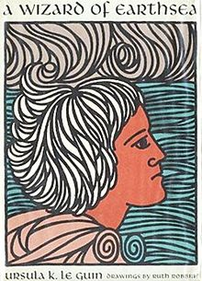
8
7
6
5
4
3
2
1
The Call
Duny saves his village and a wizard names him Ged.
The Descent

How Important is Creating Emotion?

Making your Readers Feel: The Emotional Craft of Fiction, by Donald Maass
Maass states there are three ways we generate an emotional response.
Writing is often characterized as “showing” or “telling.” “Showing” statements use what the characters say and do to communicate their thoughts and feelings. “Telling” statements explain what the characters are thinking or feeling, in expository manner. Generally, writers are counseled to avoid “telling” statements and to use “showing,” as being more engaging and interesting.
And consider Subtext, the emotional reaction we get which is not stated, yet which is unavoidable due to the way the events of the story are told. It is another way to elicit an emotional response.
We can imply characters’ inner state through showing their external actions – “Outer mode.”
And report what characters are feeling – “Inner mode.”
Further, we can “Cause readers to feel something that a story’s characters do not themselves feel” (7) – “Other mode.”

- Showing: Outer Mode
Ernest Hemingway explains how to generate emotion:
“Find what gave you the emotion; what the action was that gave you the excitement. Then write it down making it clear so the reader will see it too and have the same feeling as you had” (12).
Develop emotional showing:
Find a moment in your story when your character is upset, challenged, or moved. Write down all the emotions he or she may be feeling. Imagine all the ways your character could act to show us a feeling. Finally, tell the scene through actions and spoken words alone. Be sure your words convey the depth of feeling you had imagined.

- Telling: Inner Mode
In telling what happens in a scene, you can involve your character in such emotion that the reader recognizes the character’s feelings, which may be quite surprising.
Find a moment in your story when your protagonist feels something strongly. What is he/she feeling? What else is the character feeling? And? Look for a third-layer emotion. What is that emotion about? Morally? If the person were better, what would he/she feel? Justify having that feeling. What in the scene causes the feeling for the protagonist that only he/she can see? Add a detail in the scene that only the protagonist would see, in his/her unique way. Write a new passage for the story in which the character feels deeply this third-level emotion.

- Other Mode:
“The emotional wallop of a story is created by its totality. Readers experience that wallop when they must not just form an opinion about a story, but when they must study, question, and form an opinion about themselves. Simply put, they want to —they must— take an emotional journey” (26).

What About Historical Fiction?
The Art and Craft of Writing Historical Fiction, by James Alexander Thom
Historical fiction needs not only character development, themes, and emotional connections for the reader, it needs authentic history. As James Thom said in The Art and Craft of Writing Historical Fiction, "Some readers are learning the history of their country through the story in my novel. They didn't learn the history very well in school because it was taught in ways that were dry or boring. The historical novelist has a responsibility to keep the history as accurate as research can make it" (123). That said, of course the protagonist must grow through dramatic events, sensory details must involve the reader, and the climax must bring to life the thematic relevance of the story.

If you like writing historical fiction, you will need to do research in order to bring the setting and details to life. One tool I recommend to collect notes from online sources is Evernote. The free version is amazing.

Writing Exercise
Character Development:
- Think about your protagonist. Ask yourself questions about the character and list all the responses.
- What does he/she look like? How old? What did the person do in the past? What do they like? Dislike? Quirks? Enemies? Friends? What is the person good at? List as many details as you can about the person.

Showing Emotion:
- “Select any moment in your story when your protagonist feels something strongly. Identify the feeling. Next, ask your protagonist, ‘What else are you feeling at this moment?’ Write that down, too. Then ask, ‘Okay, what else are you feeling now?’ Write that down” (Mass 22).
- Work with that third, lower-layer emotion. Think about what it feels like to have that emotion. Could it be a problem to feel that way? Why must the character feel that way?
- Now write a new passage in which the protagonist feels deeply this emotion, giving details.

Journaling

Don’t forget the part keeping a journal can play in developing your story. Whether you write regularly or on the spur of the moment, a journal can help.

Resources:
Alderson, Martha. The Plot Whisperer: Secrets of Story Structure Any Writer Can Master. Adams Media, 2011.
Guthrie, A. B. Jr. A Field Guide to Writing Fiction, HarperCollins, 1991. (Author of The Big Sky)
Maass, Donald. The Emotional Craft of Fiction. Writer’s Digest Books, 2016.
Thom, James Alexander. The Art and Craft of Writing Historical Fiction. Writer’s Digest Books, 2010.
Strunk, William Jr., and E.B. White. The Elements of Style, 1999.
MLA Handbook, 9th Edition
Roget’s Thesaurus

